Submitted by: Taha Saifee
Everything below ran on my laptop with Spark 3.5 (Structured Streaming and Spark ML) in local mode. The scripts are in the part4_streaming folder of the project: make_stream_chunks.py builds the stream, producer.py sends it, train_model.py trains the model and streaming_app.py has the four tasks. The stream chunks are in stream_data/chunks.
Real Time Machine Learning with Spark Streaming
1. Stream Processing and Data Aggregation:
- Implement a Spark Streaming application that reads a stream of data simulating real-time bank transactions. The stream should include columns such as 'age', 'job', 'balance', 'duration', and 'y' (target variable). You can create this stream by breaking the "bank.csv" dataset into smaller chunks and sending them as a simulated stream.
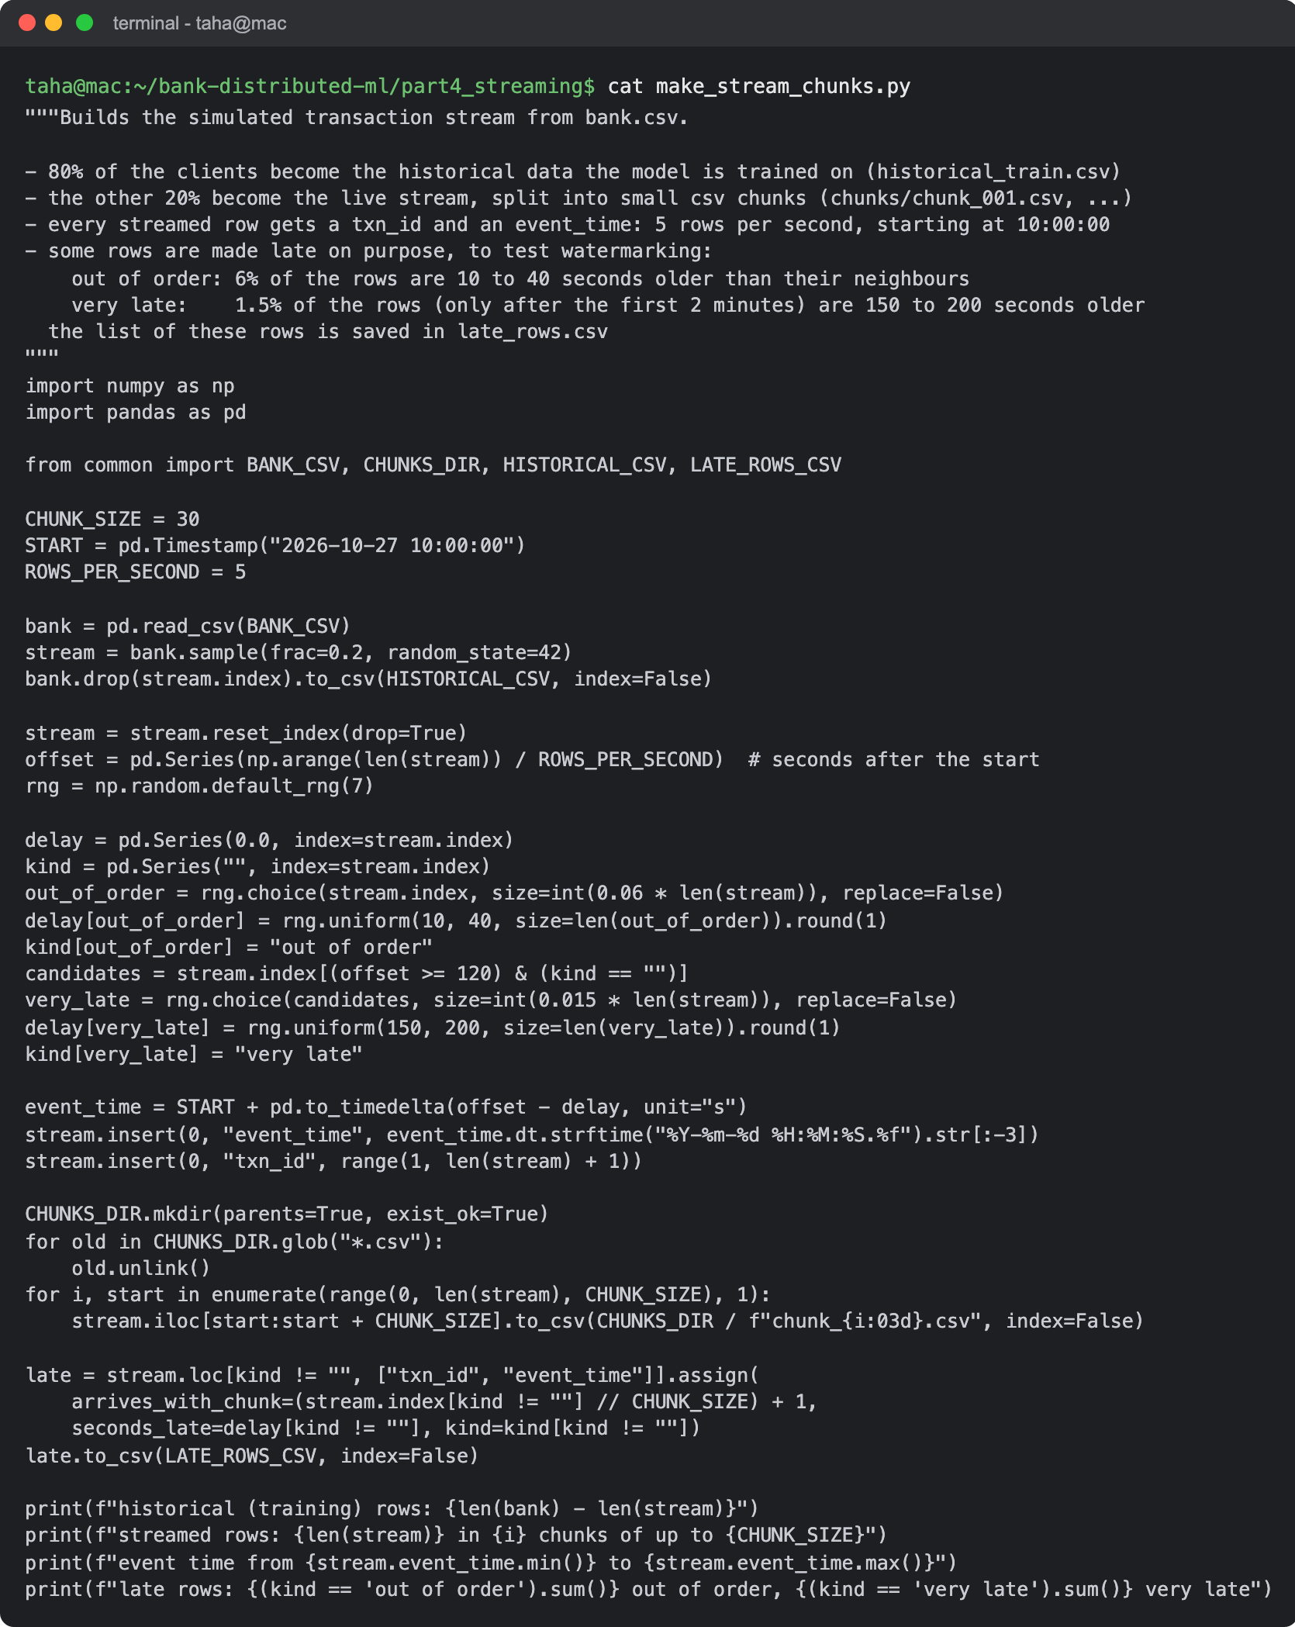
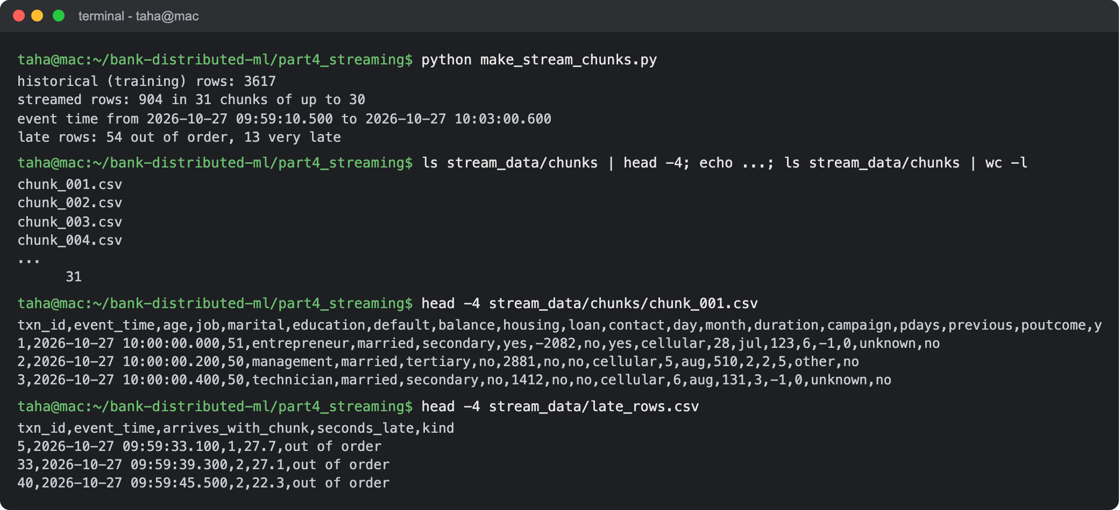
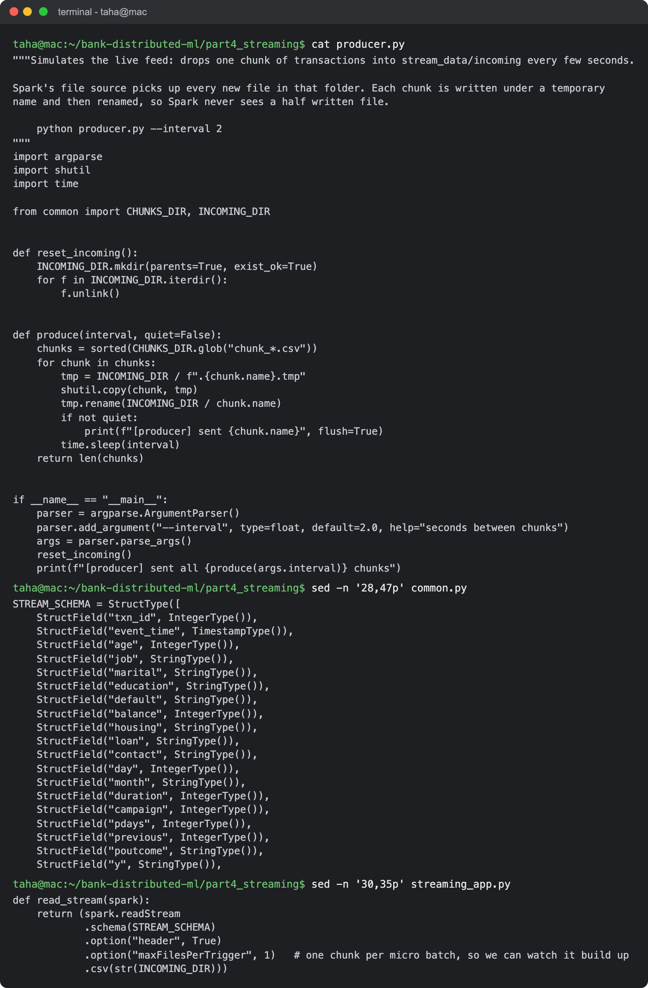
Answer: How the stream is built: I split bank.csv into two parts. 80% of the clients (3,617) are the historical data used to train the model, and the other 20% (904) are the live transactions. These are cut into 31 csv chunks of 30 rows, and every row gets a txn_id and an event_time (5 transactions per second starting at 10:00:00). To test the watermark later, 54 rows are made out of order (10 to 40 seconds older than their neighbours) and 13 rows are made very late (150 to 200 seconds old). The list is in late_rows.csv.
How it is read: producer.py copies one chunk every couple of seconds into stream_data/incoming, like an outside system sending transactions. Spark reads that folder with readStream as a csv stream, with a fixed schema (a stream can't infer one) and maxFilesPerTrigger = 1, so every chunk becomes one micro batch and we can watch the results build up. I used Structured Streaming, the current Spark streaming API, and set spark.sql.shuffle.partitions to 4 because the default of 200 is far too many for batches of 30 rows.
- Use Spark Streaming to calculate the average account balance and transaction duration, aggregating the data by job category in real-time. Display the aggregated results as they are updated.
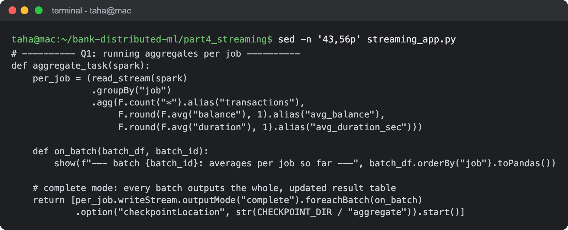
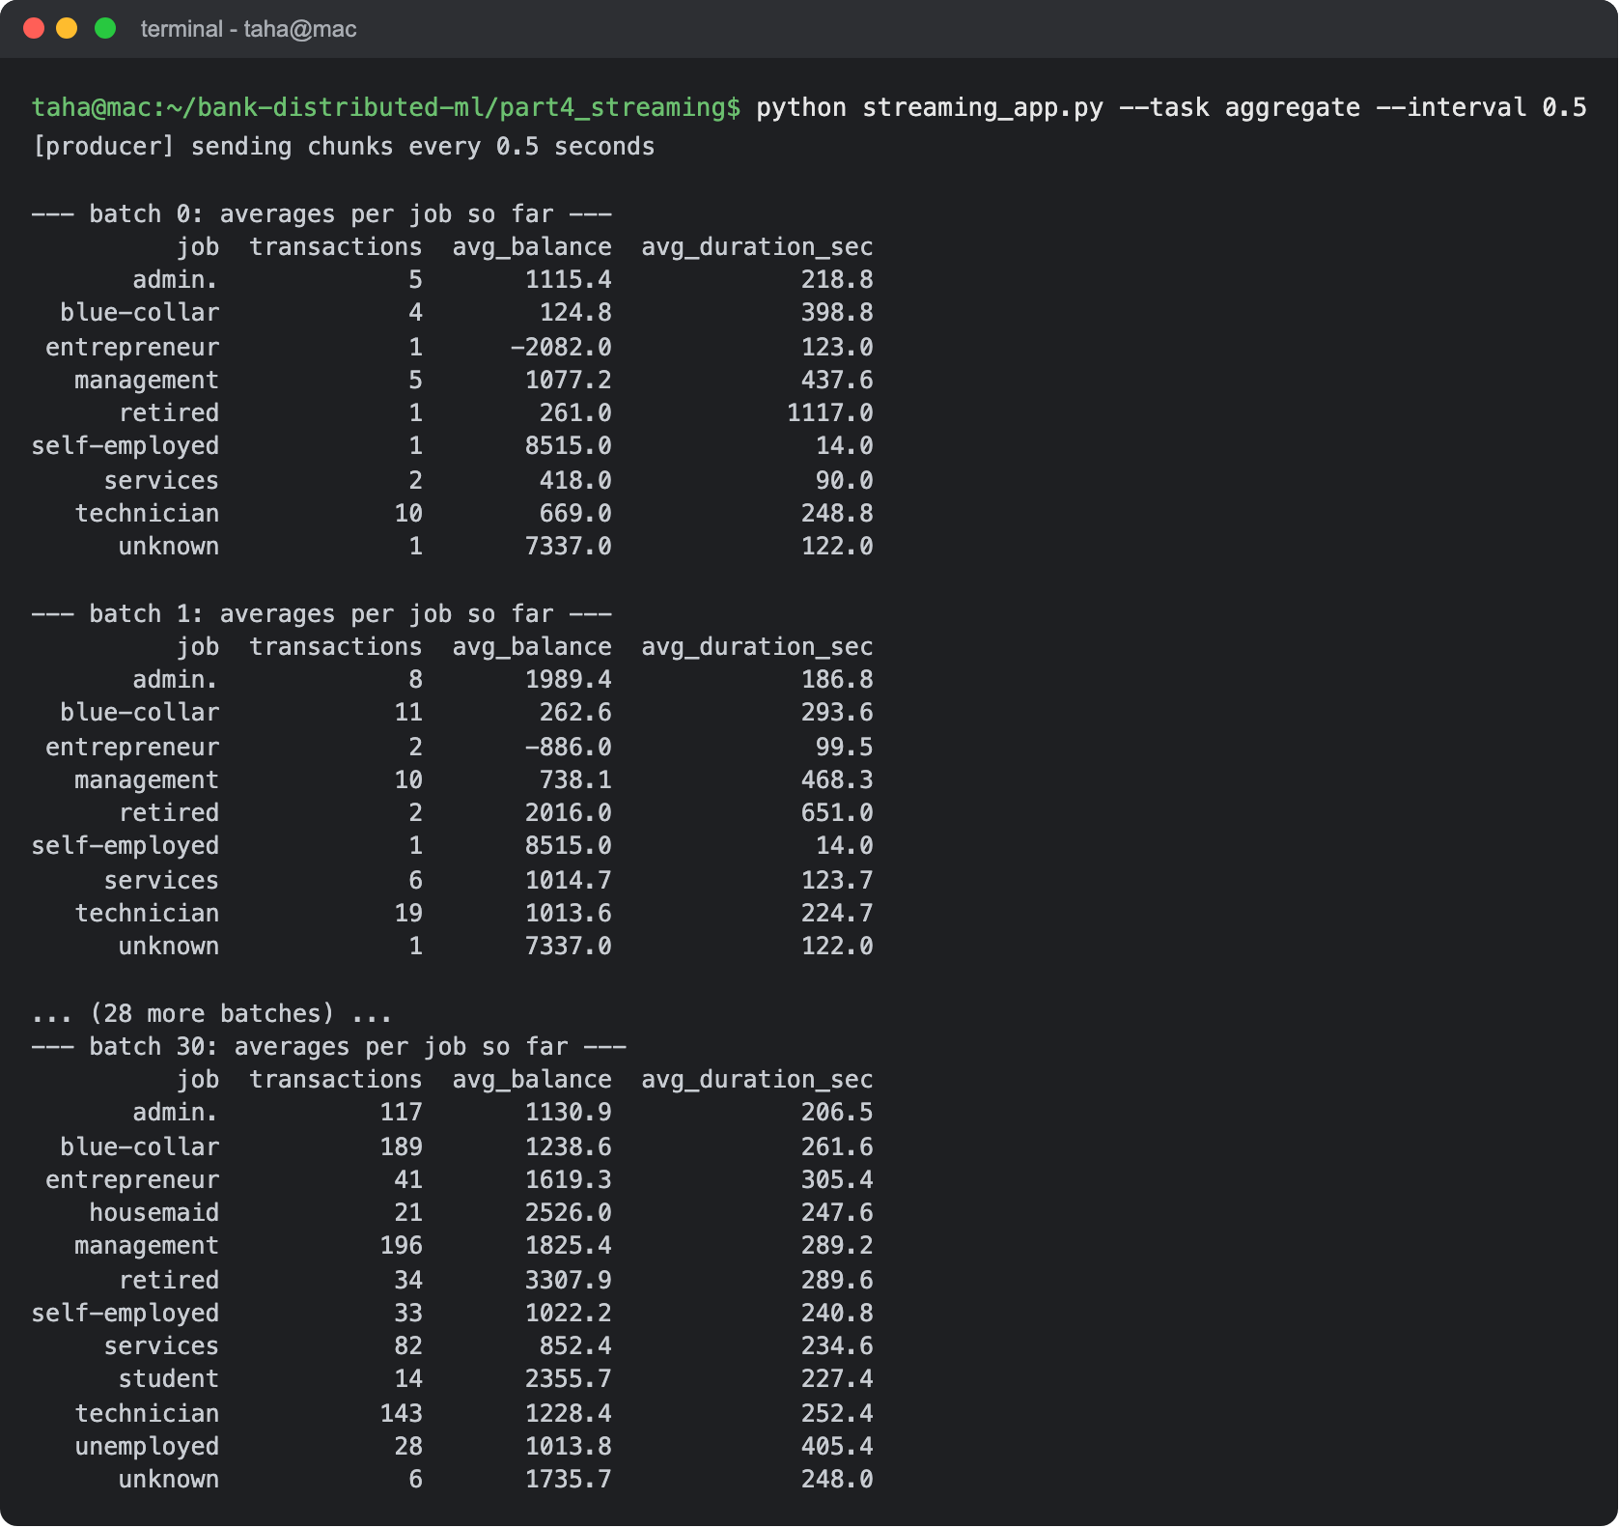
Answer: The query groups the stream by job and keeps the number of transactions, the average balance and the average duration up to date. It uses complete output mode, so after every micro batch the whole updated table is printed. After batch 0 only 30 transactions are in, and after the last batch (batch 30) all 904 are. In the final table, management and blue-collar clients have the most transactions (196 and 189), retired clients the highest average balance (3,307.9) and unemployed clients the longest calls (405.4 seconds on average).
2. Real-Time Model Predictions:
- Develop a machine learning model using the historical data from the "bank.csv" dataset to predict whether a client will subscribe to a term deposit ('y'). You may choose any classification algorithm.
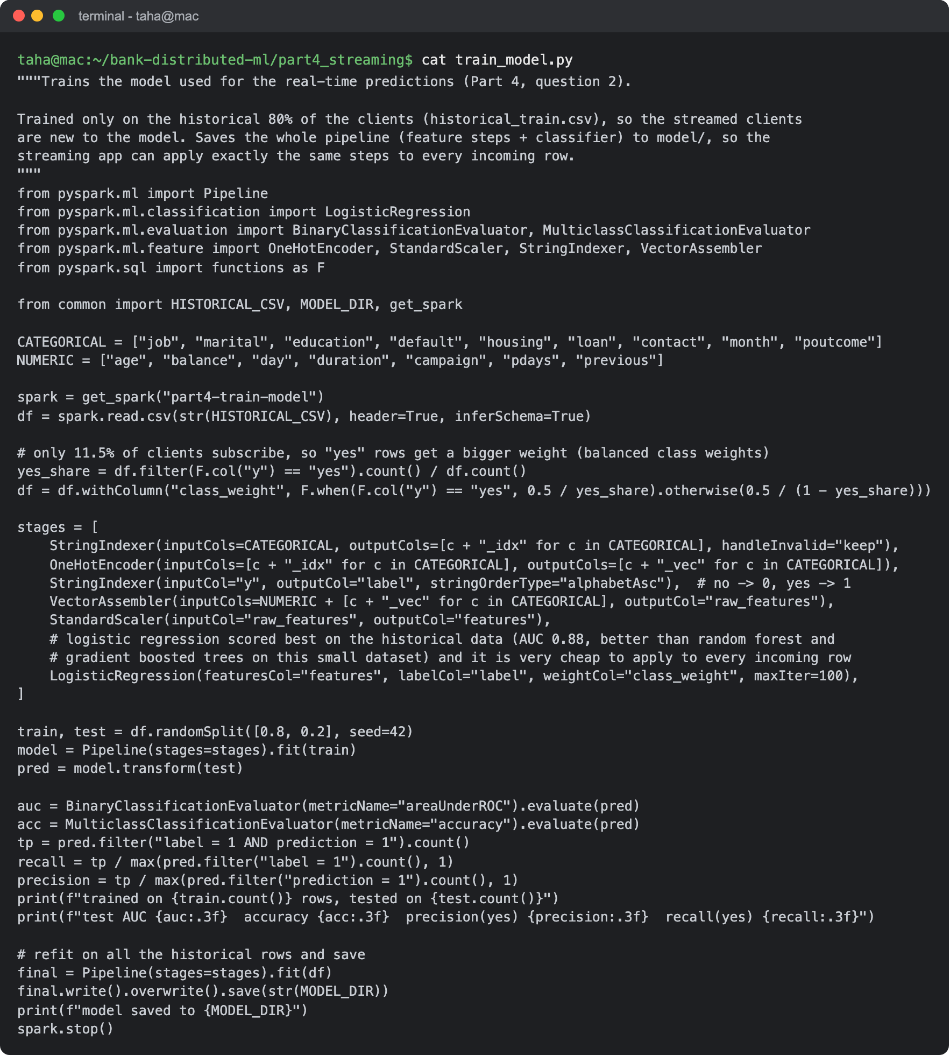
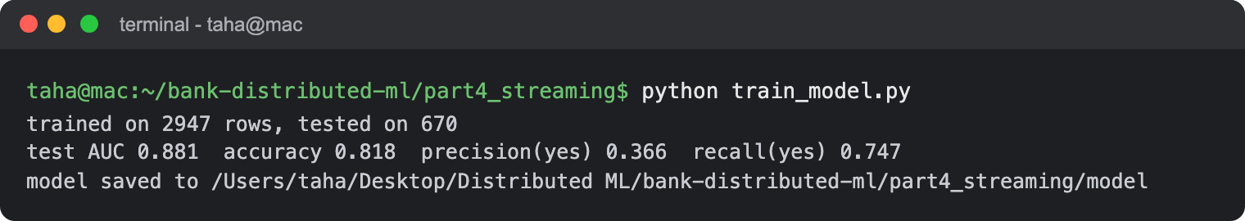
Answer: The model is a Spark ML pipeline: StringIndexer and OneHotEncoder for the text columns, VectorAssembler, StandardScaler and a logistic regression. Only 11.5% of clients subscribe, so I gave the "yes" rows a bigger weight (balanced class weights), otherwise the model would mostly predict "no". It is trained only on the historical 80%. On a test split of that data it gets an AUC of 0.881, 81.8% accuracy and finds 74.7% of the subscribers. I also tried a random forest (AUC 0.853) and gradient boosted trees (0.847), and logistic regression was the best here and is also the cheapest to apply to every incoming row. The whole pipeline is saved to the model folder.
- Integrate the trained model into the Spark Streaming application. Use the model to make real-time predictions as new transaction data is streamed. Ensure that each incoming transaction is accompanied by a prediction of whether the client will subscribe to a term deposit.
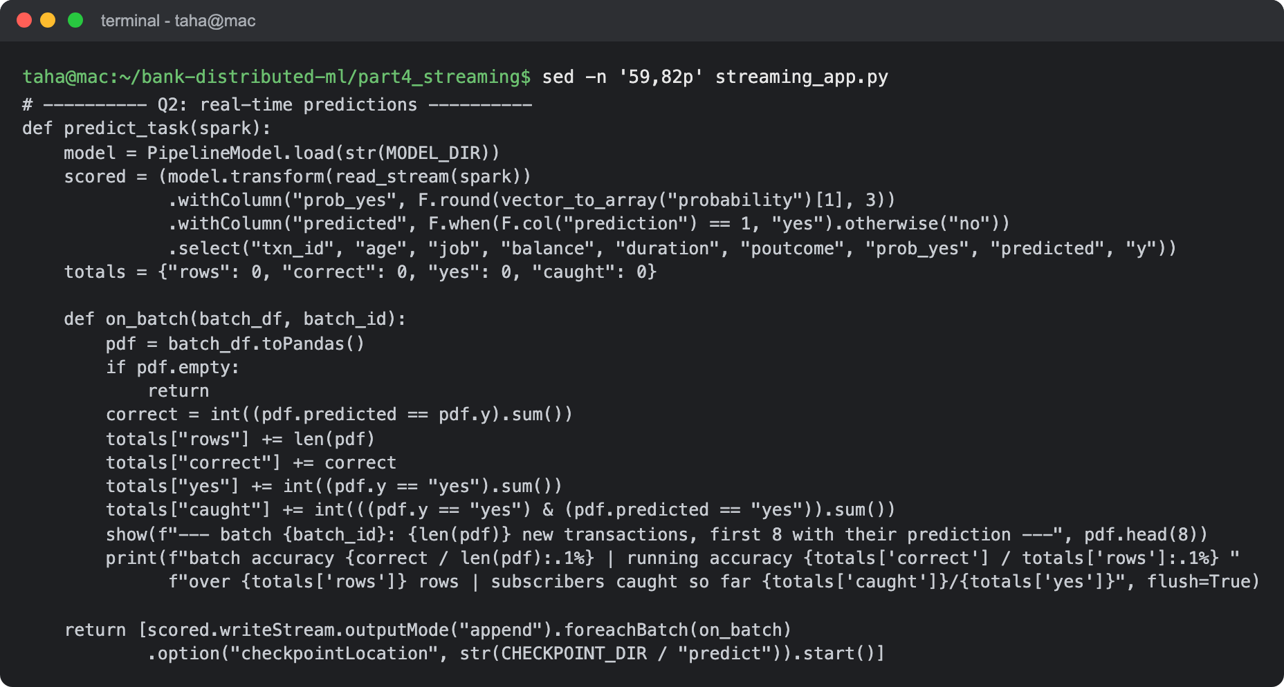
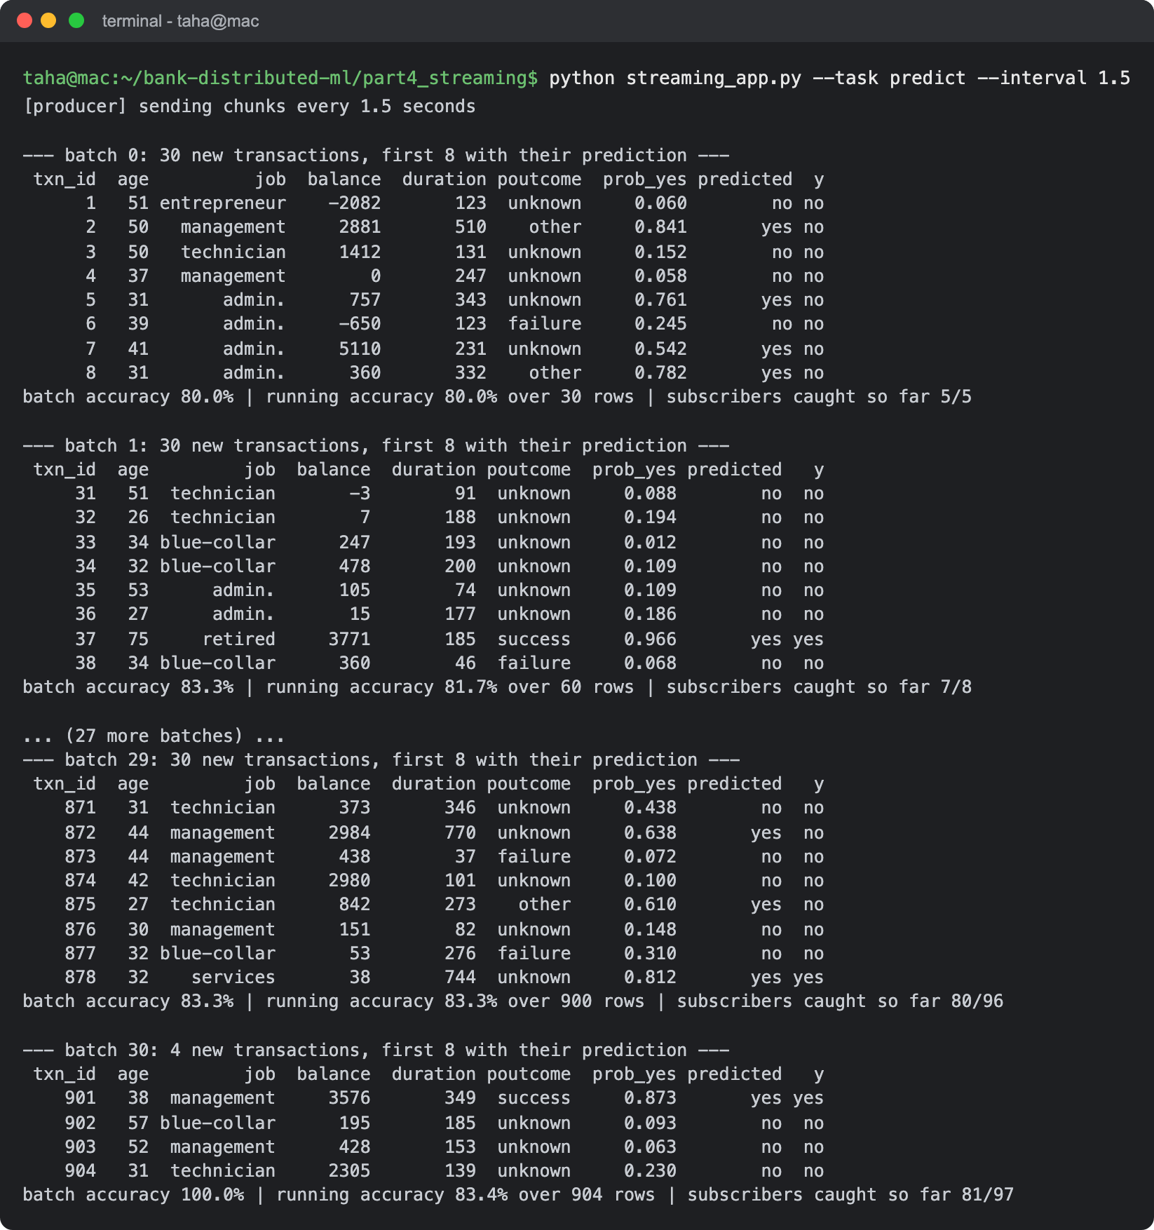
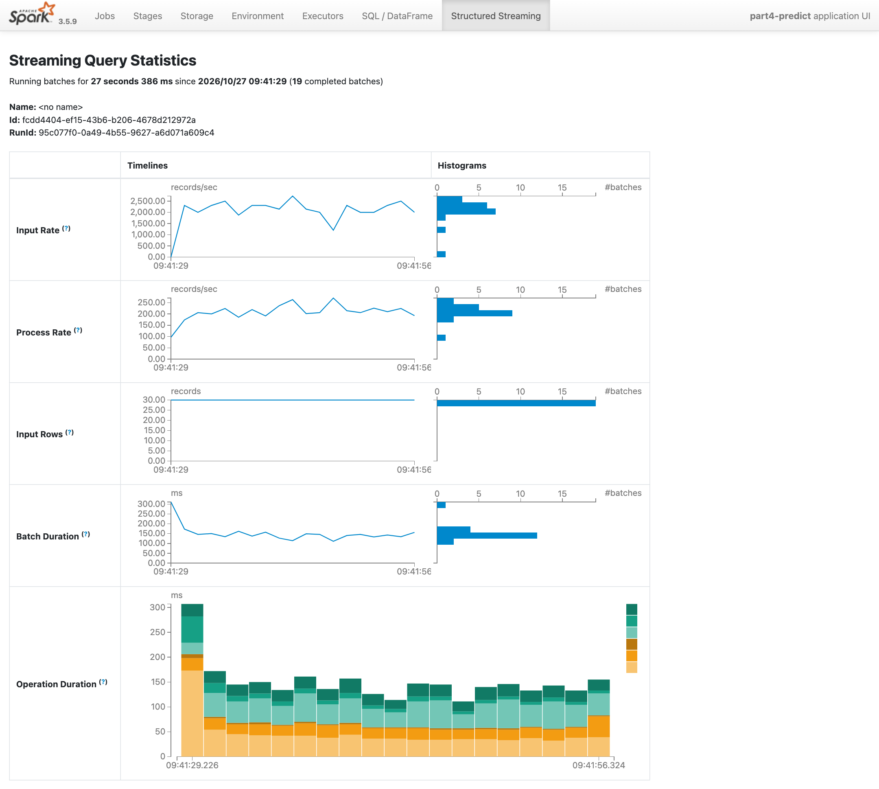
Answer: The streaming app loads the saved pipeline and calls model.transform on the stream, so every transaction gets a probability of subscribing (prob_yes) and a predicted label as soon as it arrives. Because the stream still has the real answer (y), I can check the model live: after all 904 streamed clients the accuracy is 83.4%, and it flagged 81 of the 97 clients who really subscribed. These clients were never seen during training. The Spark UI screenshot is from this run: 30 rows per batch, about 150 ms per batch and around 200 rows per second processed.
3. Window Operations and Trend Analysis:
- Implement window operations in your Spark Streaming application to analyze trends over different time windows (e.g., 10 seconds, 1 minute). Calculate and display the count of transactions and the average balance within these windows.
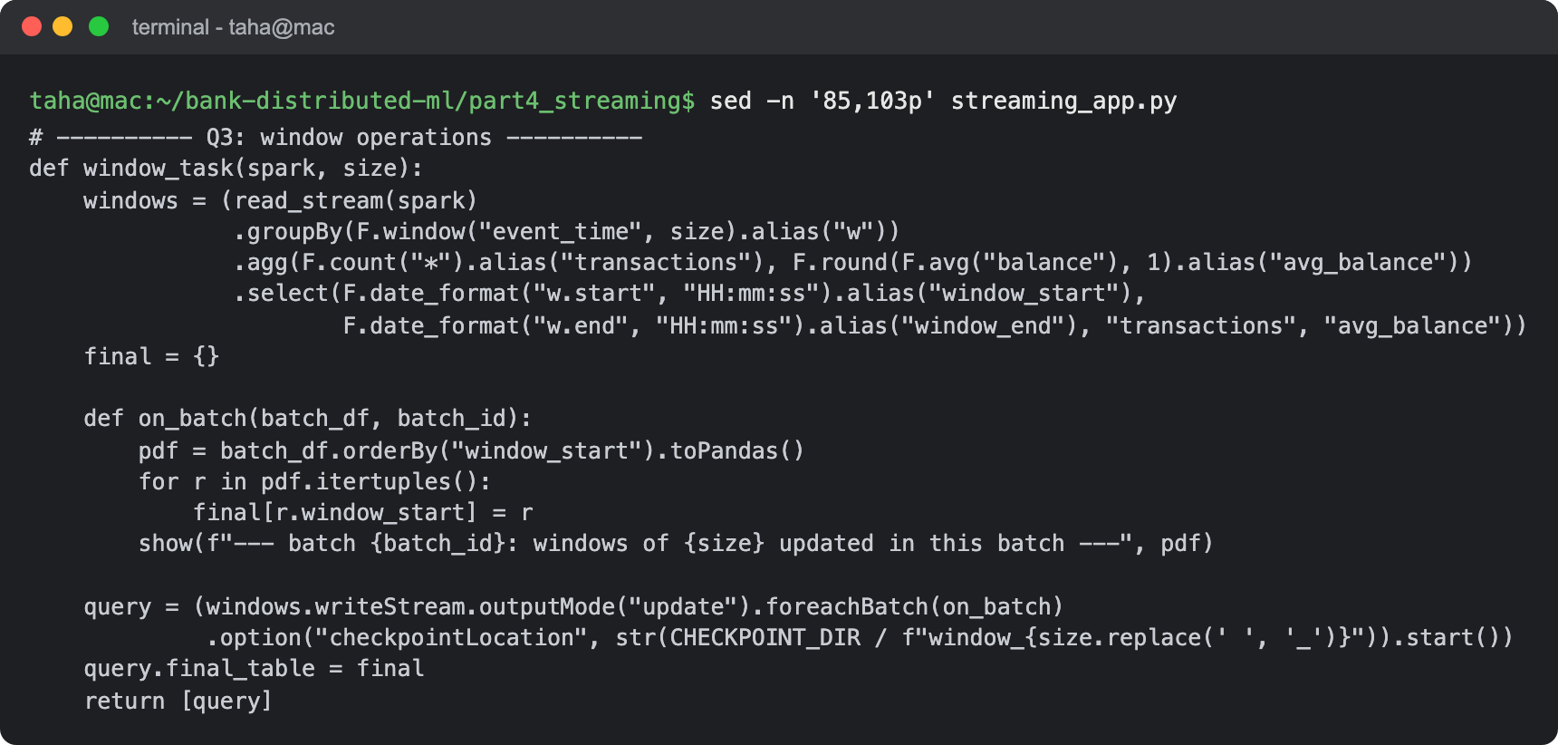
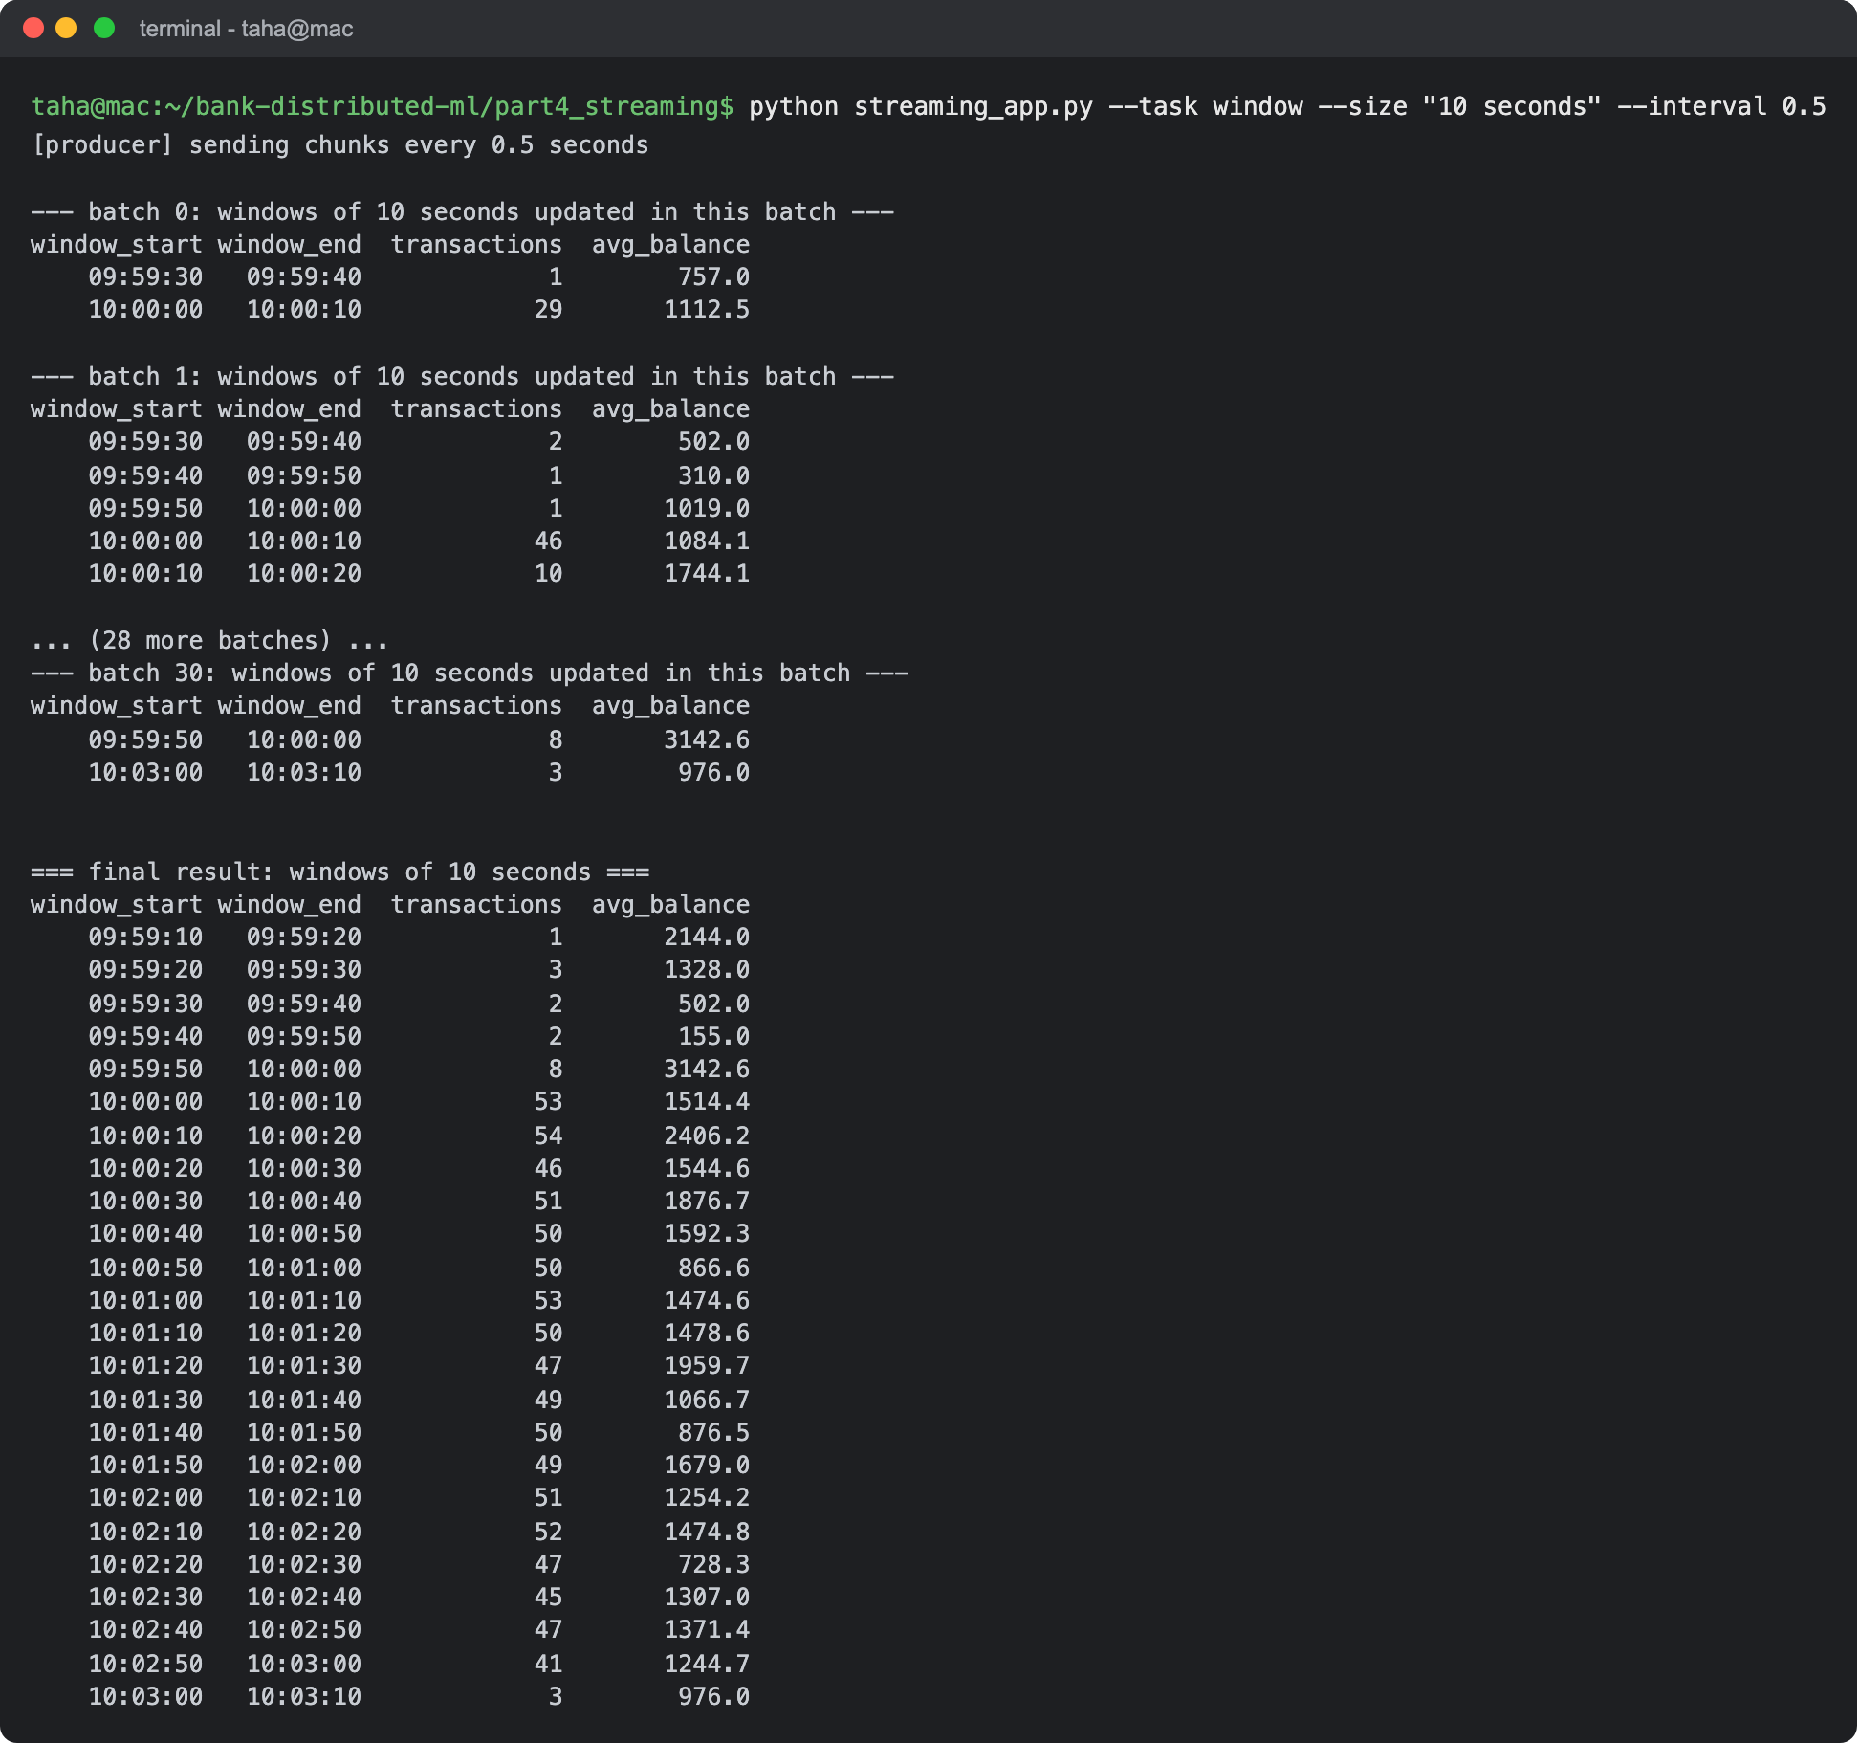
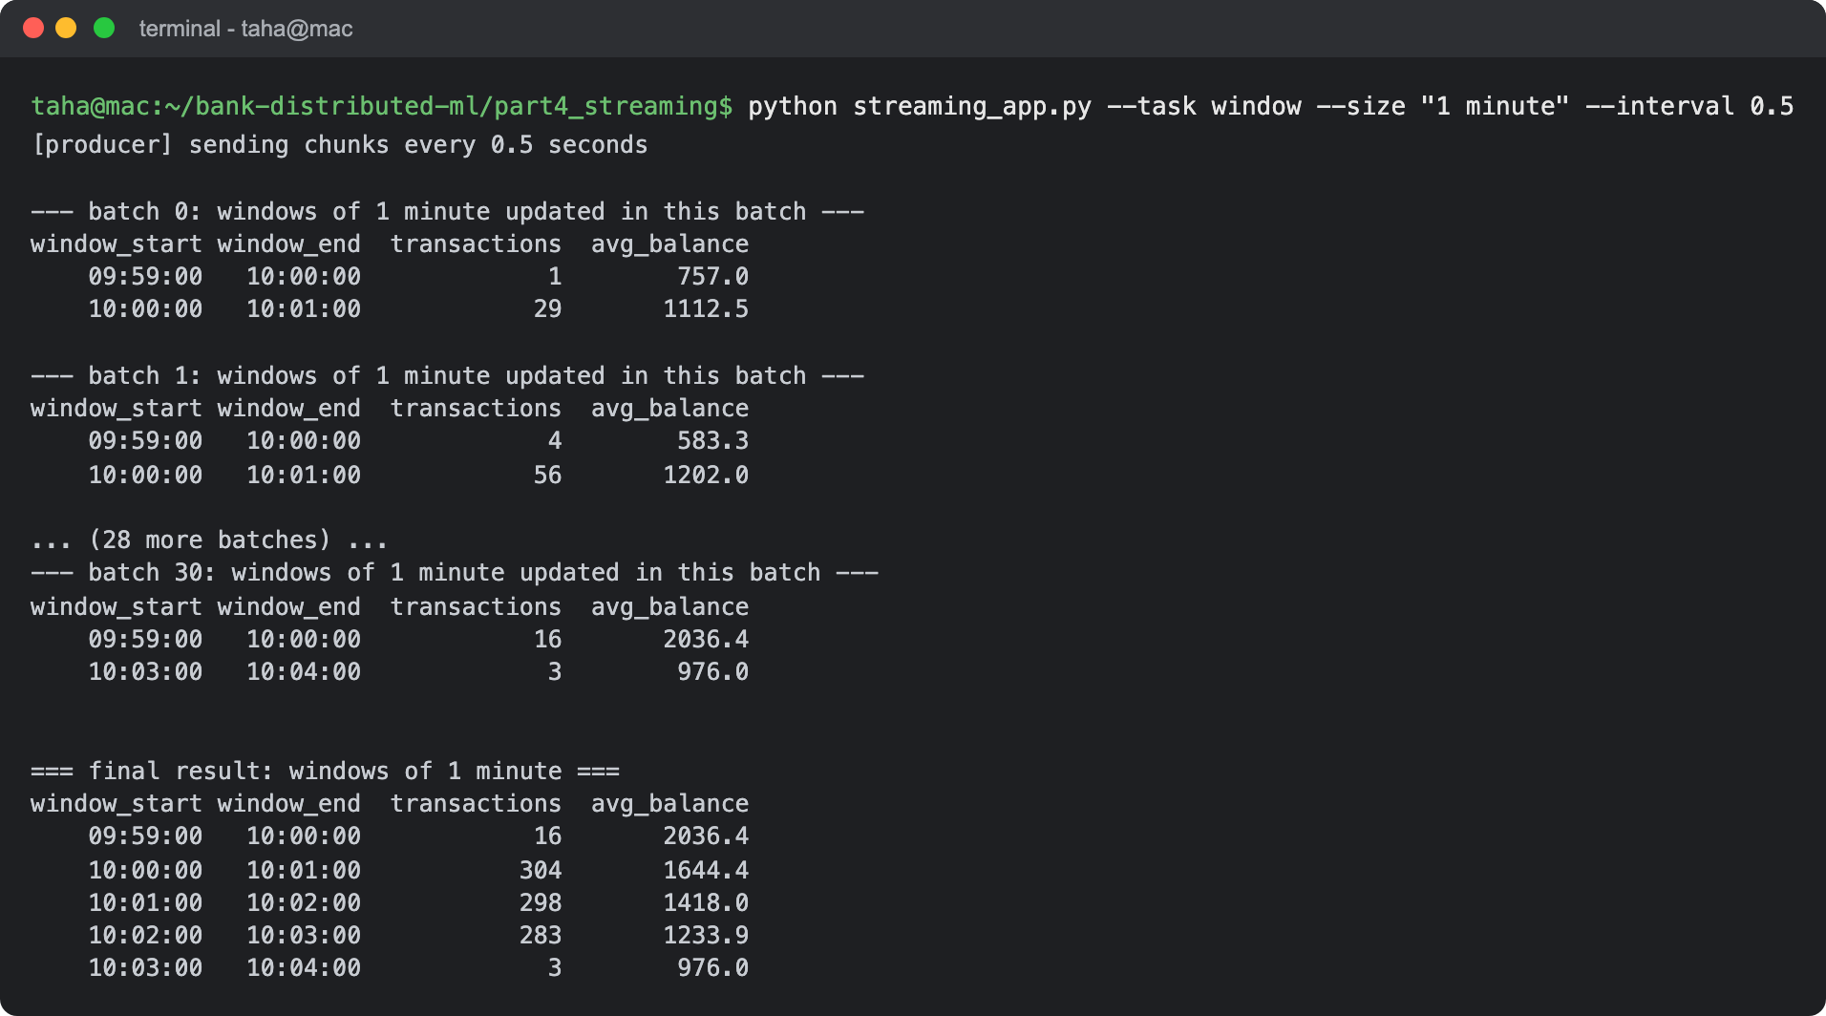
Answer: The windows are tumbling windows on event_time (when the transaction happened, not when it arrived), of 10 seconds and of 1 minute. For each window the query counts the transactions and averages the balance. It runs in update mode, so each batch prints only the windows that changed, and at the end the app prints the full table.
- Write a brief analysis of the trends observed in the streaming data. Discuss any interesting patterns or anomalies detected in the transaction count or average balance over the specified windows.
Answer: Transaction count: with 5 transactions per second a full 10 second window should have 50, and almost all of them have between 45 and 54. Windows below 50 lost a few rows that were sent out of order, and those rows show up in earlier windows. The small windows before 10:00:00 (1 to 8 transactions each) only exist because of late rows. The last window, from 10:03:00, has only 3 rows because that is where the stream ends.
Average balance: between 10 second windows it jumps around a lot, from 728 (10:02:20) to 2,406 (10:00:10), and 3,143 in the small 09:59:50 window. One client with a very high balance is enough to move a small window. With 1 minute windows it is much smoother: 1,644, 1,418 and 1,234 for the three full minutes. That is the trade-off between window sizes: short windows react quickly but are noisy, long windows are stable but slower to show a change.
The slow drop over the three minutes is not a real trend. The order of the clients in the stream is random, so it is just which clients landed in which minute. In a real bank feed, a sudden jump in count or average balance in one window is exactly the kind of anomaly that would trigger an alert.
4. Handling Late and Out-of-Order Data:
- Modify your Spark Streaming application to handle late and out-of-order data using watermarking. Explain your approach and how it improves the accuracy of real-time analytics.
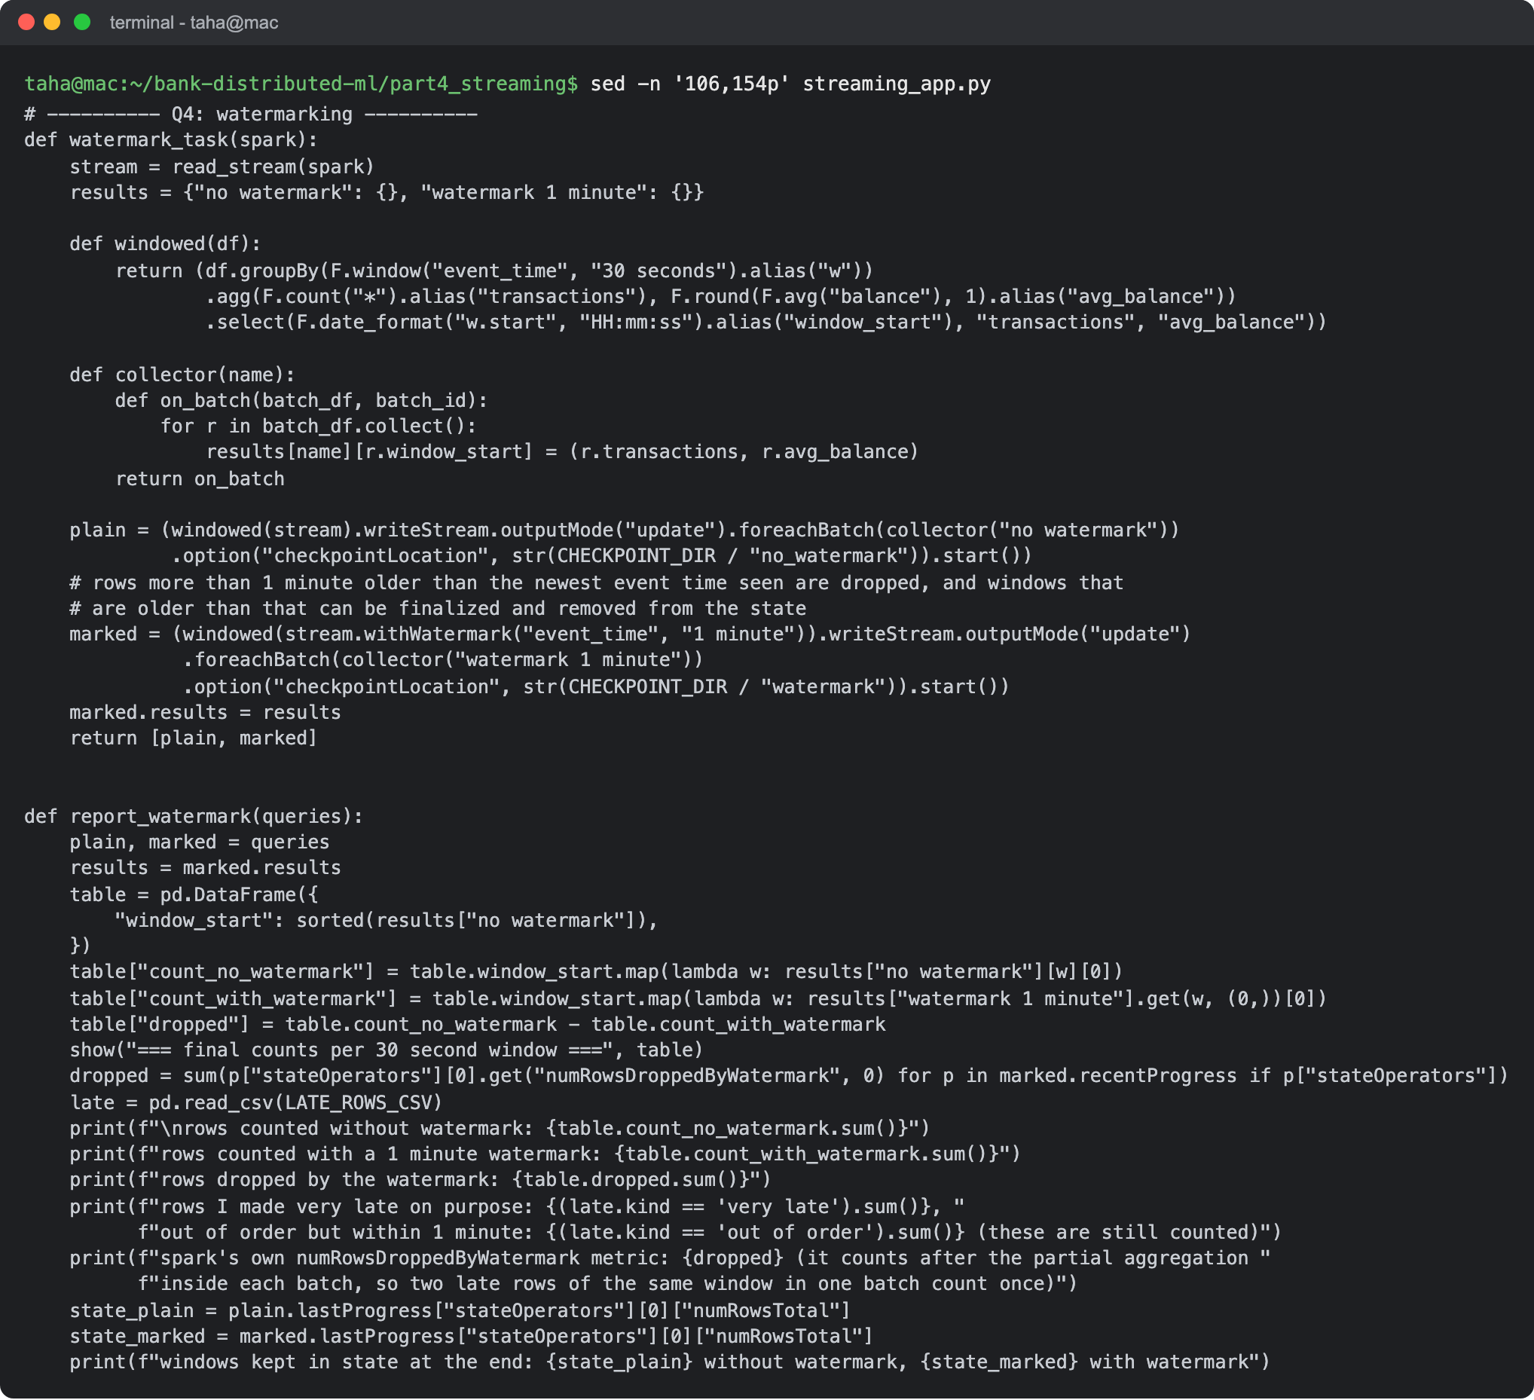
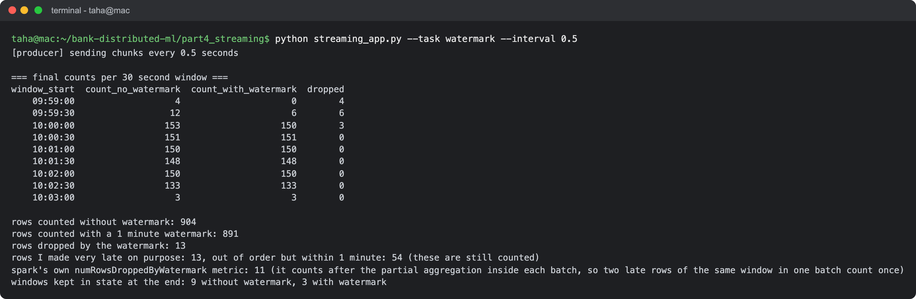
Answer: Approach: withWatermark("event_time", "1 minute"). Spark remembers the newest event time it has seen and accepts rows that are up to 1 minute older than that. Older rows are dropped, and windows older than the watermark are final, so their state can be removed from memory. To show the effect, the app runs the same 30 second window count twice on the same stream, once without a watermark and once with it.
Result: 904 rows are counted without the watermark and 891 with it. The 13 rows that were dropped are exactly the 13 rows I made 150 to 200 seconds late, and they are in the windows where their event time falls (4 in 09:59:00, 6 in 09:59:30, 3 in 10:00:00). All 54 out-of-order rows, which are 10 to 40 seconds late, are still counted, and they are counted in the window they belong to. Spark's own numRowsDroppedByWatermark metric shows 11 because it counts after combining rows inside a batch, so two late rows of the same window in one batch count once. At the end only 3 windows are kept in memory with the watermark, against 9 without.
Why it makes real-time analytics more accurate: windows are based on when a transaction happened, so a late transaction still lands in the right window instead of the window of when it arrived. The watermark also stops the state from growing forever, which matters for an app that runs for days. The price is that data later than the threshold is lost, so the threshold should match how late data really arrives. If some bank systems send their transactions 5 minutes late, the watermark should be at least 5 minutes.

Submission Guidelines:
- Make a copy of this doc file.
- Complete your Spark Streaming tasks in your local development environment.
- Provide screenshots of both the code and the output under each question.
- Upload the doc file with other files and submit it in the submission dashboard.
- If there are any additional scripts, data files, or resources used in your project, include them in your submission.

